**Command Lines**

**IFCONFIG**

Check the ip address and configuration assigned to the system.

**Traceroute**

Displays the routers the packet passes on its path to the destination.

**DIG command**

Returns the answers returned by DNS records

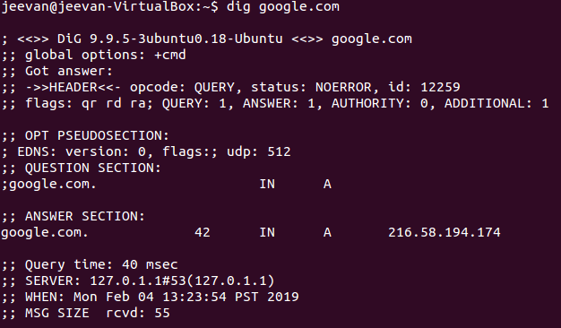

**Telnet**

To check connectivity between two hosts.

telnet hostname portno

**NSLOOKUP**

To find entries on the DNS servers

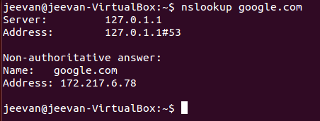

**NETSTAT**

Summary of all ports connected and their status

**W**

Summary of current activity on the host

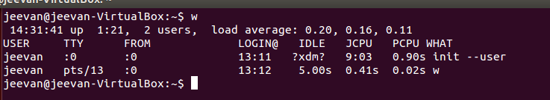

**NMAP**

Checks the open ports on the server

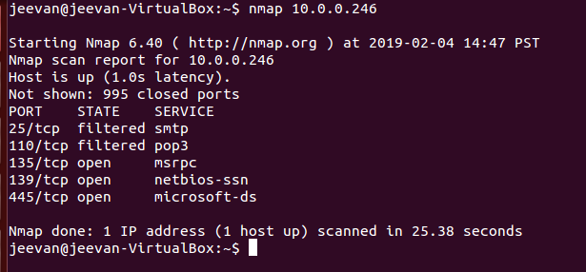

https://www.tecmint.com/nmap-command-examples/

**IFUP / IFDOWN**

To enable or disable a network interface.

Example

Ifup eth0

Ifdown eth0

**SCP**

Secure copy files from other hosts in the network

**ARP command**

ARP table on the host machine

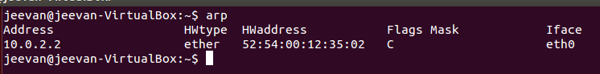

**Route Command**

Routing table on the host machine

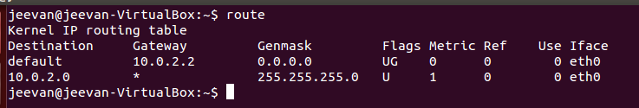

Adding a default gateway

route add -net <ipaddress> gw <gateway ipaddress>

default gateway

route add default gw <gateway ip address>

**HOST Command**

Name to ip and Ip to name

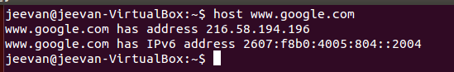

**Checking Network Connectivity Issues**

1. Check LAN and WAN connections
2. Verify wireless adapter
3. Verify AP and router settings.
   1. Verify SSID details (network parameters)
   2. Identify the subnet and whether the client has the ip address.
   3. Verify if the ip address of your desktop is assigned by the router.
4. Verify TCP/IP setting in the desktop.
5. Use ping to verify connectivity.
6. Check wireless specifications issue whether standards.

**Client Connectivity Issues**

Normal Connection Proceedure

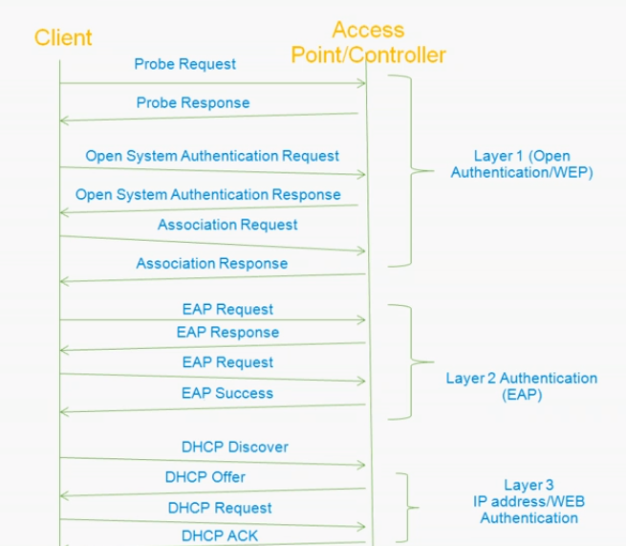

**Layer 1 Authentication**: To find all the available SSIDs or Available wireless networks over the air. After the response. Association request is sent. Agreeing to IEEE formats 802.1 or any.

**Layer 2 Authentication**: Authentication over data link layer.

Possible problems:

Wrong EAP authentication,

**Layer 3**: To get an IP address.

Possible problems:

DHCP proxy enable or disable

SSID mismatch

**Troubleshooting Client:**

3 commands:

1. debug client <MAC address>
2. show debug 🡪 Policy manager state important one that gives status
3. debug disable-all

Client details

Show client <Mac address>

Client Connectivity

https://community.cisco.com/t5/wireless-mobility-videos/troubleshooting-client-connection-issue-on-cisco-wireless/ba-p/3102725